 | Project Design Phase-II
 | Data Flow Diagram & User Stories
Date | 05 October 2022
Team ID | PNT2022TMID12583
Project Name | Exploratory Analysis of Rainfall Data in India for Agriculture
Maximum Marks | 4 Marks

Data Flow Diagrams:

A Data Flow Diagram (DFD) is a traditional visual representation of the information flows within a system. A neat and clear DFD can depict the right amount of the system requirement graphically. It shows how data enters and leaves the system, what changes the information, and where data is stored.

0 – LEVEL DATA FLOW DIAGRAM:

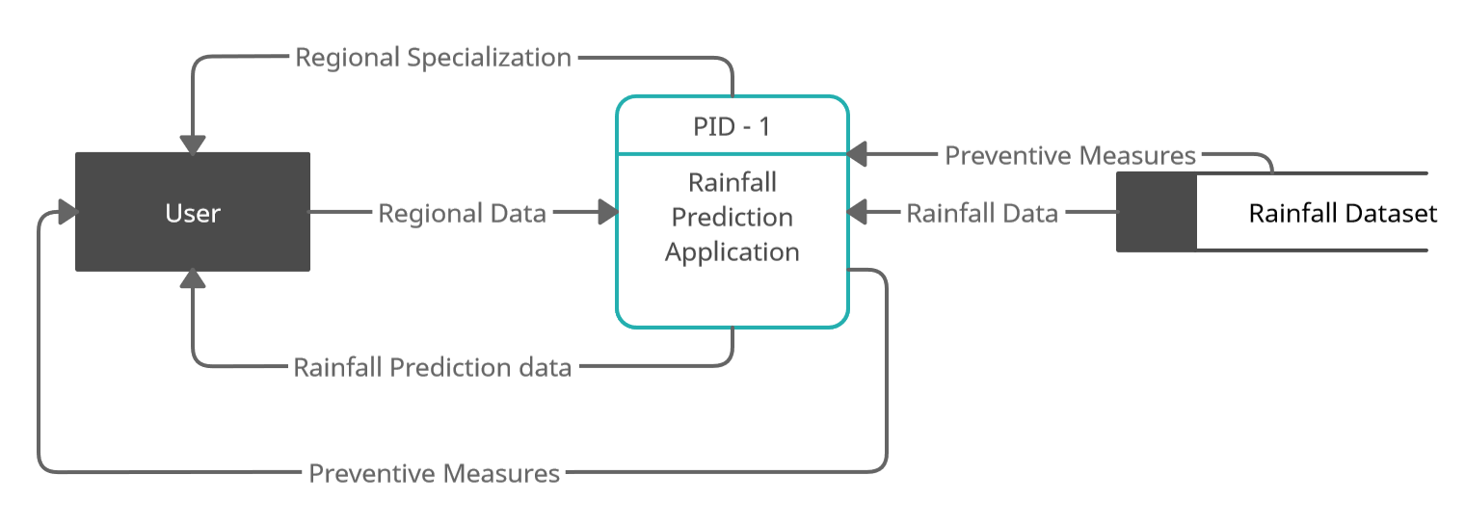

1 – LEVEL DATAFLOW DIAGRAM :

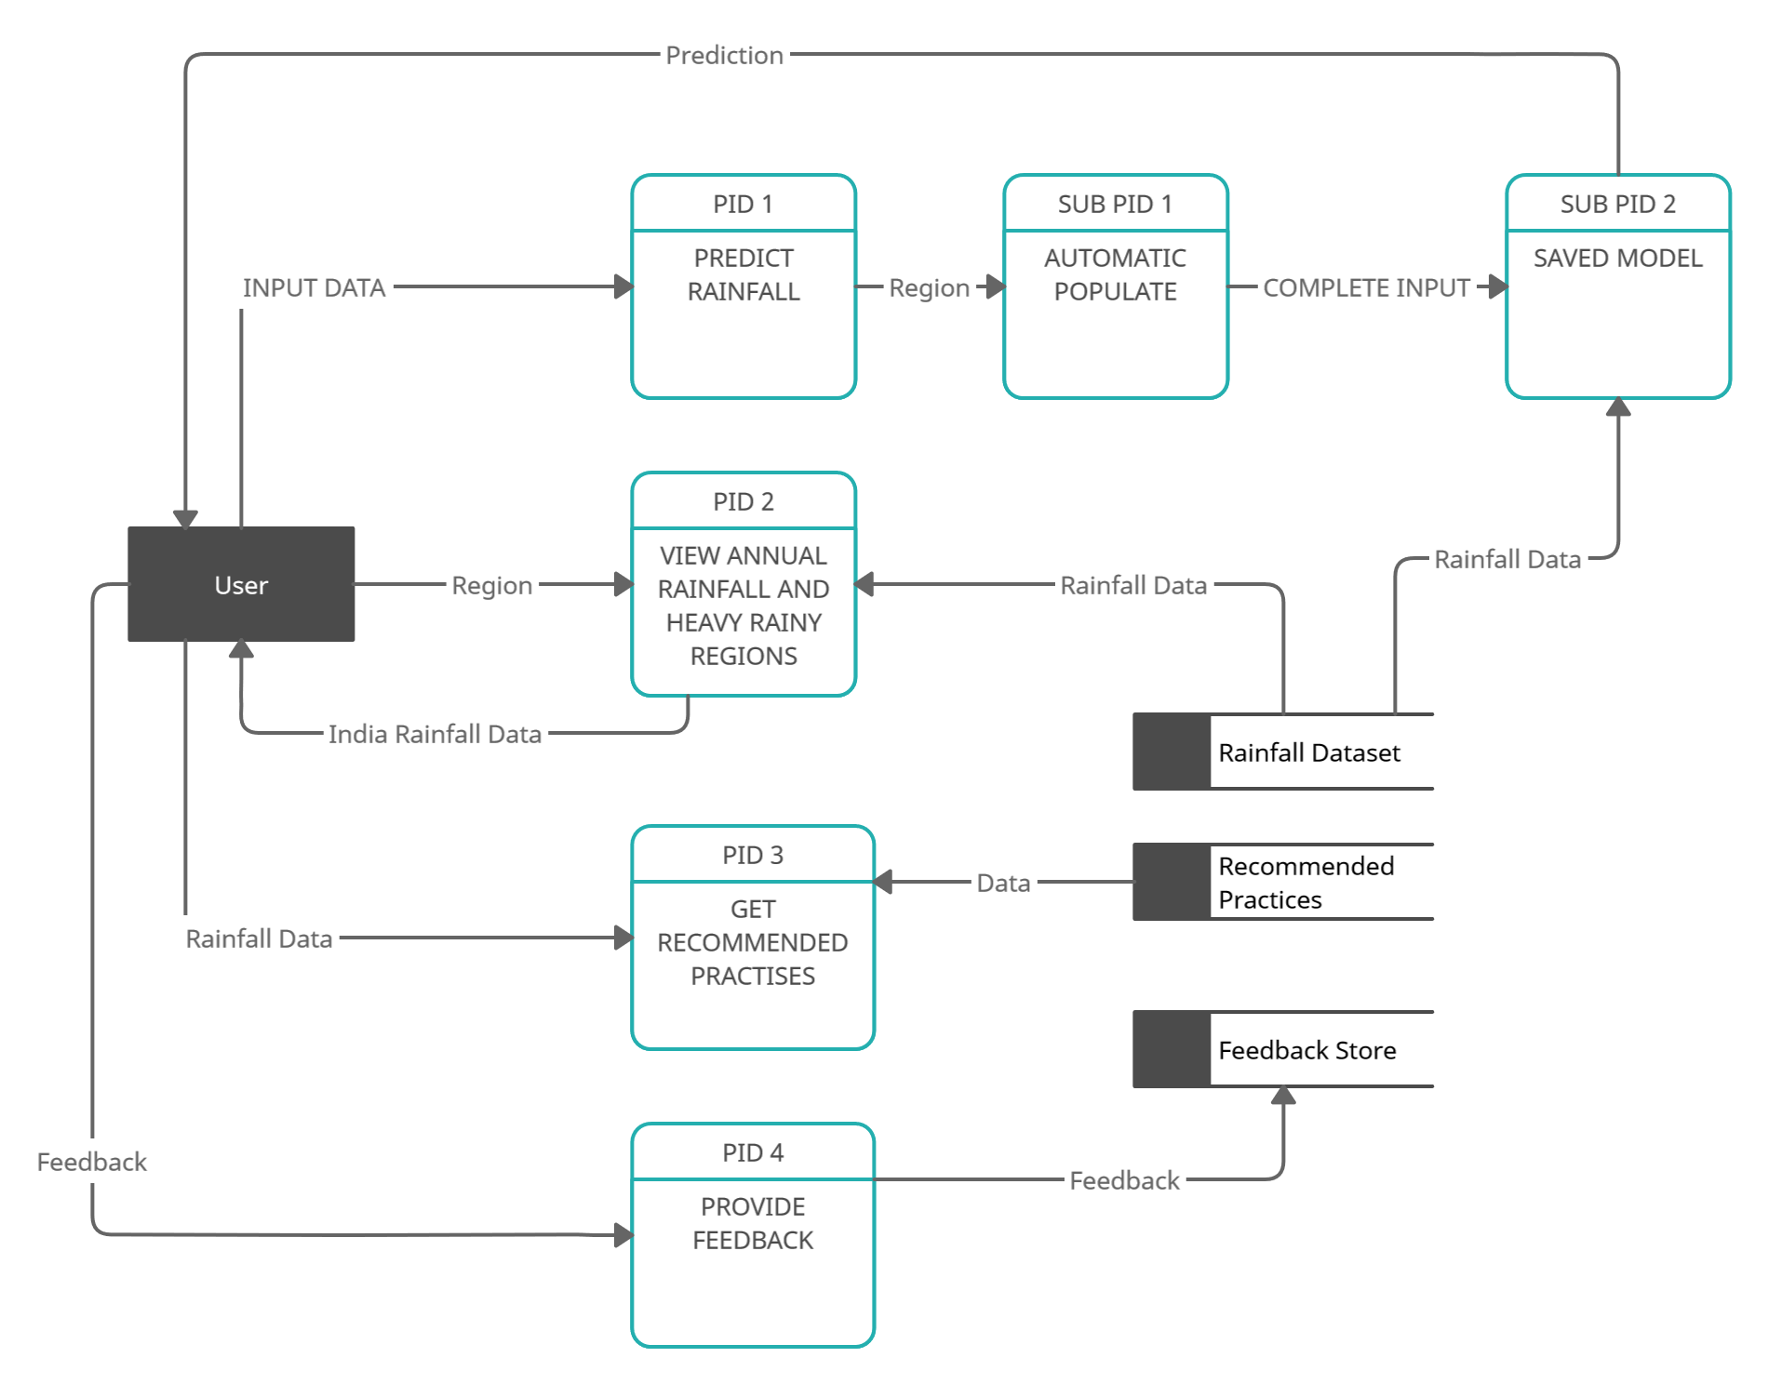

2 – LEVEL DATA FLOW DIAGRAM :

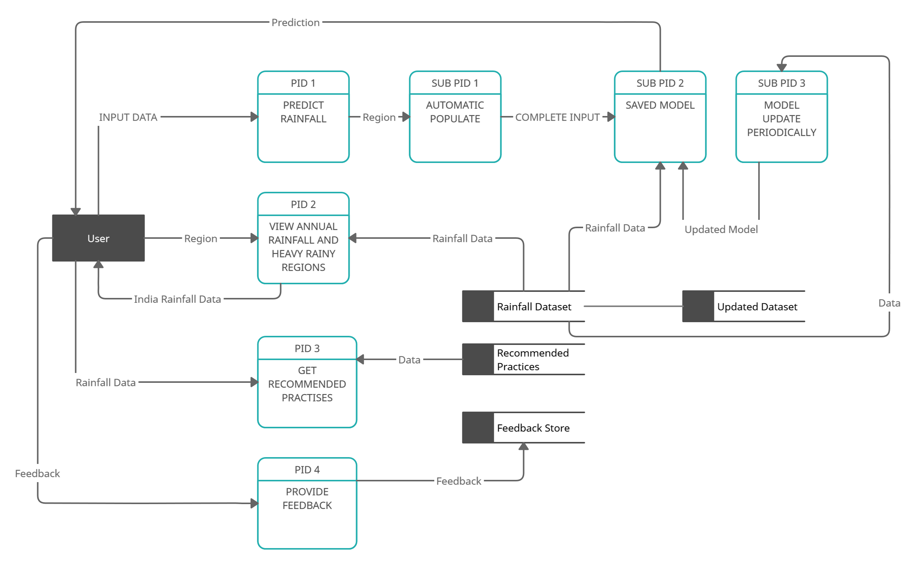

User Stories

Use the below template to list all the user stories for the product.

User Type | Functional | User Story | User Story / Task | Acceptance criteria | Priority | Release
 | Requirement | Number
 | (Epic)
User in | Basic Form Template | USN-1 | Develop a simple html file with a basic form where users can provide their inputs like they can select their region of interest, wind direction etc. | User should be able to select any region in India and enter the values | High | Sprint-1
Website
 | Auto Fill Inputs | USN-2 | The input fields must be auto filled If the user is not sure about the values given the region | The inputs must get auto filled once the region is selected | High | Sprint-1
 | Basic Flask Server | USN-3 | A basic flask server that has all the necessary routes and integrated with the website |  | Medium | Sprint-1
 |  |  | A basic flask server that has all the necessary routes and integrated with the website | The corresponding functions must execute correctly once route is hit and checked by tools like postman
Backend Team | Model Building and Testing | USN-4 | Construct Machine Learning models trained on the pre-processed dataset and observe their accuracy. | Queries can be raised in | High | Sprint-2
 |  |  | Save the Models as .pkl file | situation of doubts
Frontend Team | Design the website and add all required pages | USN-5 | Develop Website with all the required pages |  | High | Sprint-2
 |  |  |  | All necessary pages must be developed and appropriate content is filled
 | Add Recommended Features | USN-6 | Recommend best practises based on the rainfall | The user will get all their | High | Sprint-2
 |  |  |  | doubt clarified
 | Visualisation | USN-7 | Add Visualisation for rainfall data across all the states in India | The visualisations has to be dynamically loaded and charts must be responsive | High | Sprint-3
 |  |  | Update the ML model with the updated dataset | Model stays up to date | High | Sprint - 3
Developer team | Auto Update Model | USN - 8

